2026 Flea Market
Articles of Agreement
for the 48th Annual
Maumee Valley Summer Show
DATE Change: JULY 23-26, 2026
Daily Admission $5
or $10 for all four days

Flea Market
The Association agrees to furnish dealer space during the annual show July 23-26 2026

Vendor/Dealer agrees to pay for display space used on the following basis: (Please check one)

___ (Open Air) 20’ X 40’ With electricity $70.00
(No air conditioners)
___ (Open Air) 20’ x 40’ No electricity $60.00

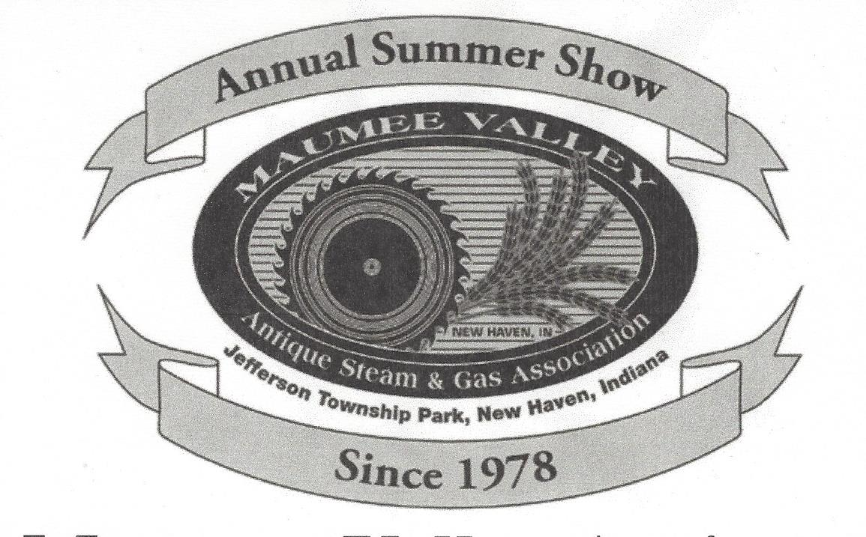

Articles of Agreement between the Maumee Valley Antique Steam and Gas Association,
New Haven, IN and:

Name: __________________________________

Address:________________________________

City:_________________State:_____Zip:_____

Emergency Contact/Phone Number: _____________________________________ (_____)___________________________

I will be selling: ________________________________________________________________________________________

Any other special requests or requirements: __________________________________________________________________

Vehicle description: ______________________________________________________________________________________
Two (2) individual passes given per dealer upon arrival. Additional daily passes extra.
Display space location will be assigned upon arrival at the show unless previous arrangements are made. Setup may begin Tuesday, July 21, 2026 at 8:00 am. Vendor/Dealers must report to John Rorick for space assignment prior to setting up their display. No dealer is permitted to set up without a signed contract. Vendor/Dealers who have not returned a contract before July 9, 2026 will be provided space on a first-come, first-served basis. Vendor/Dealers are required to remain setup until Sunday, July 23, 2026 at 3:00 pm and to clean up their area before leaving. Drive-in Vendor/Dealers are always welcome. Maumee Valley Antique Steam and Gas Association assumes no responsibility for the Vendor/Dealer complying with the Indiana State Tax Laws or Merchant’s requirements. A camping fee will be assessed to dealers after 5:00 p.m. Monday, July 27,2026. Pre-packaged foods and fresh produce may be sold. Selling any type of drinks or concession-type food is prohibited. No alcoholic beverages permitted. Inappropriate items and behavior will not be tolerated and you will be asked to leave. Pets must be on a leash and not allowed to be in contact with the public. All pet owners shall be responsible for clean-up of all pet droppings. If cancellation/ notification is not given before July 9, 2026 any deposits will not be returned.
NOTE: Show is located east of New Haven, IN between U. S. 24 and U. S. 30 at 1720 Webster Road (corner of Webster and Dawkins Roads. Map and more information at (maumeevalley.org)
Please sign and return one (1) copy of this agreement by July 6, 2026 to John Rorick, 2903 South Ryan Road, New Haven, IN 46774. Cell phone: 260-341-6152. Make checks payable to: Maumee Valley Antique Steam & Gas Association.

By: _________________________________________________ _________________________________________________
Dealer Signature/Date Flea Market Manager/Date

Total Remittance: _______________________Check No. ____________Date____________

Dealers shall be liable for and shall indemnify and hold harmless Maumee Valley Antique Steam & Gas Association, its individual officers, directors, officers and agents from and against any liability, claim, loss damage or expense arising out of any injury or death to any person or any damage to any property resulting from or in connection with the Dealers use or occupancy of the facility. Indemnification shall include all claims, unless claims arise out of the sole negligence of Maumee Valley Antique Steam & Gas Association or its agents.

Keep for your records

Please consider this letter your special invitation to participate in our 48th Annual Summer Tractor and Engine show, July 23-26, 2026 sponsored by the Maumee Valley Antique Steam and Gas Association. We will be featuring Allis-Chalmers, and Rumely Oil Pulls, garden tractors and gas engines. All other exhibitors are also welcome.

The show includes exhibits of antique cars, trucks, steam engines, gas engines, tractors, garden tractors, a trading post, flea market and quilt display. Activities conducted during the show include sawmill operation, shingle mill operation, threshing, plowing, tractor pull Friday and Saturday and blacksmith demonstrations. The Dekalb County Horseman will be providing hay rides Friday and Saturday and the Flying Circuits will be conducting model airplane flying demonstrations.

Electric hookups will be assigned on a first-come, first-served basis. Insurance is required. Returning your contract early will assure you the space you request.

NOTICE: THE ELECTRICAL SERVICE IN THE FLEA MARKET AREA HAS BEEN UPDATED

The park grounds will be open at 8:00 a.m. on Tuesday, July21, 2026 for exhibitor/vendor set-up. On arrival, please register at the Main Office. Exhibitors/vendors are required to remain set up until Sunday,July 26, at 3:00 p.m. and to clean up their area before leaving. Show hours on Thursday, Friday and Saturday are 9:00 a.m. - 9:00 p.m. and from 9:00 a.m. - 3:00 p.m. on Sunday.

Enclosed is a show flyer and two Flea Market Contracts. Please complete and return one (1) copy of the contract with your check payable to Maumee Valley Antique Steam & Gas Association and send them to John Rorick, 2903 Ryan Road, New Haven, IN 46774. If you have any questions, please contact John at 260-341-6152.

Contacts: Show, Tony Herman - 260-414-9489; Quilts, Brenda Schuller - 260-580-5285; Flea Market & Camping, John Rorick - 260-341-6152; Trading Post -Karen Washler - 260-460-0569; Model Show, John Schamber – 260-485-9104; Exhibitors, Roger Schuller - 260-580-5416; Garden tractors and gas engines – Roger Flint - 419-796-9635 or Alex Heine 260-705-8226.

Thank you for considering our show and we look forward to seeing you.

John Rorick, 260-341-6152

